Release with TAG ICS components

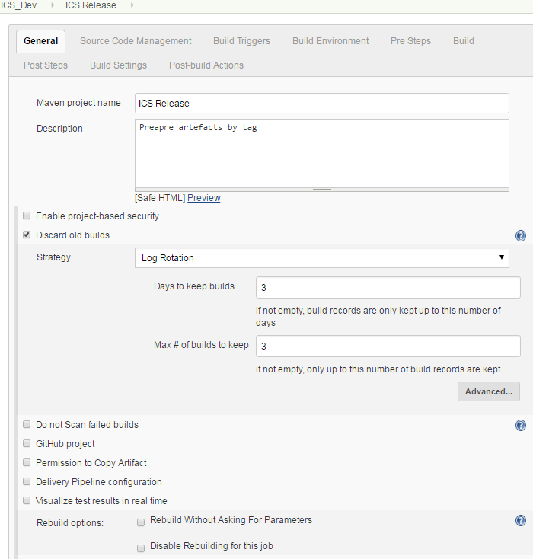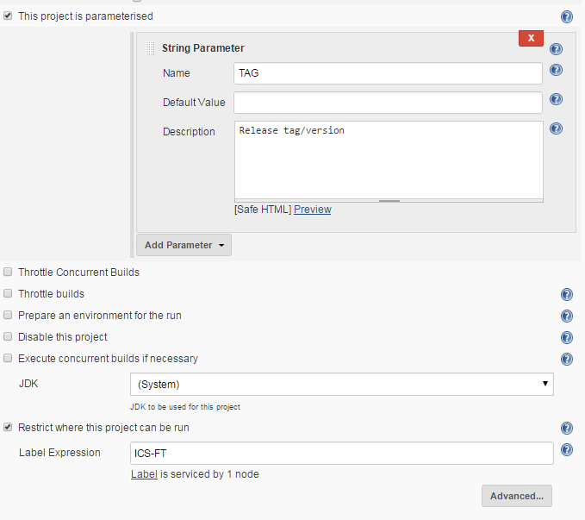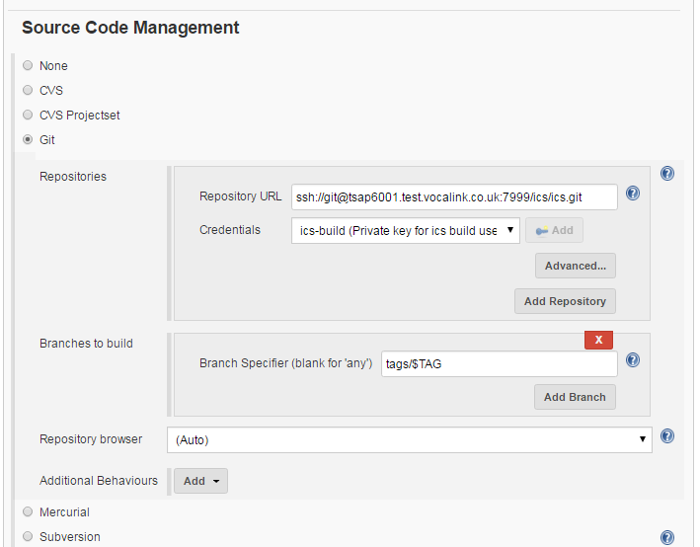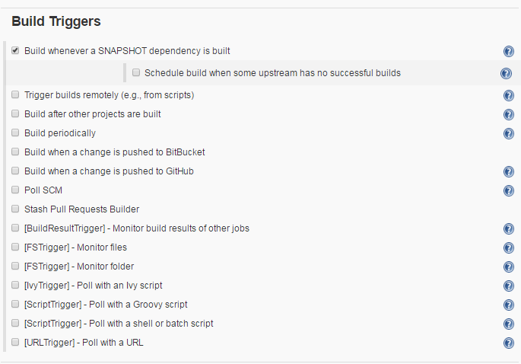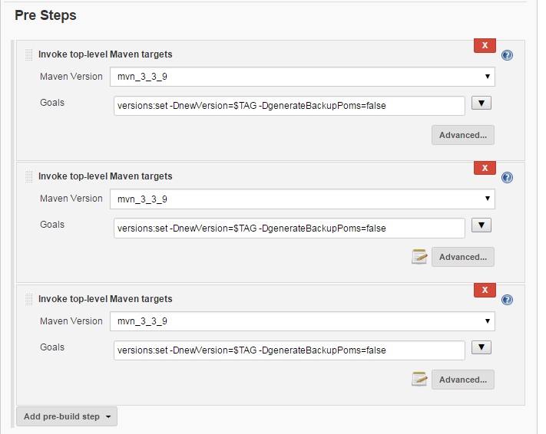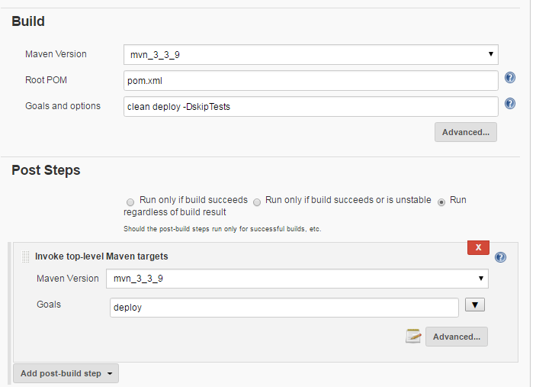

**POM.xml**

<!--

~ Copyright (c) 2017 VocaLink Ltd

-->

<project xmlns="http://maven.apache.org/POM/4.0.0" xmlns:xsi="http://www.w3.org/2001/XMLSchema-instance"

xsi:schemaLocation="http://maven.apache.org/POM/4.0.0

http://maven.apache.org/maven-v4_0_0.xsd">

<modelVersion>4.0.0</modelVersion>

<groupId>com.vocalink.ics</groupId>

<artifactId>ics</artifactId>

<packaging>pom</packaging>

<version>0-SNAPSHOT</version>

<name>ICS Gateway Solution</name>

<properties>

<build.version>0</build.version>

<project.build.sourceEncoding>UTF-8</project.build.sourceEncoding>

<project.reporting.outputEncoding>UTF-8</project.reporting.outputEncoding>

<svn.revision>1</svn.revision>

<vocalink.error-handler.version>0.0.12</vocalink.error-handler.version>

<vocalink.events-transport.version>0.0.1-SNAPSHOT</vocalink.events-transport.version>

<vocalink.ics-rest-core-client.version>0.0.6</vocalink.ics-rest-core-client.version>

<vocalink.identity-token-transport.version>0.3.1</vocalink.identity-token-transport.version>

<vocalink.signature-service.version>0.2.0</vocalink.signature-service.version>

<!-- Dependency versions -->

<apache.commons.beanutils.version>1.9.2</apache.commons.beanutils.version>

<apache.commons.fileupload.version>1.3.2</apache.commons.fileupload.version>

<apache.commons.io.version>2.5</apache.commons.io.version>

<apache.commons.lang.version>3.4</apache.commons.lang.version>

<aspectjweaver.version>1.8.10</aspectjweaver.version>

<assertj-core.version>3.6.2</assertj-core.version>

<bouncy-castle.version>1.54</bouncy-castle.version>

<camel-jpa.version>2.18.1</camel-jpa.version>

<camel-mail.version>2.17.3</camel-mail.version>

<camel-saxon.version>2.17.3</camel-saxon.version>

<camel-velocity.version>2.17.3</camel-velocity.version>

<camel.version>2.18.1</camel.version>

<com.ibm.mq.version>8.0.0.5</com.ibm.mq.version>

<cxf.version>3.1.7</cxf.version>

<cyclops.react.version>1.0.5</cyclops.react.version>

<guava.version>19.0</guava.version>

<hamcrest.version>1.3</hamcrest.version>

<hibernate.version>5.2.4.Final</hibernate.version>

<httpclient.version>4.5.3</httpclient.version>

<jackson.jaxrs.version>2.8.8</jackson.jaxrs.version>

<jai-imageio-core.version>1.3.1</jai-imageio-core.version>

<janino.version>3.0.7</janino.version>

<javax.validation-api.version>1.1.0.Final</javax.validation-api.version>

<javax.ws.rs-api.version>2.0.1</javax.ws.rs-api.version>

<jbehave.version>4.0.5</jbehave.version>

<jcabi-matchers.version>1.3</jcabi-matchers.version>

<jms-api.version>2.0</jms-api.version>

<json-web-token.version>0.7.0</json-web-token.version>

<jsp-api.version>2.0</jsp-api.version>

<jstl.version>1.2</jstl.version>

<junit.version>4.12</junit.version>

<kezsign-client-utils.version>2.1.1</kezsign-client-utils.version>

<logback.version>1.1.8</logback.version>

<mockito.version>1.10.19</mockito.version>

<modelmapper.version>0.7.5</modelmapper.version>

<oracle.ojdbc7.version>12.1.0.2</oracle.ojdbc7.version>

<orcle.aqapi.version>12.1.3-0-0</orcle.aqapi.version>

<powermock.version>1.6.5</powermock.version>

<restassured.version>2.9.0</restassured.version>

<servlet.version>3.1.0</servlet.version>

<spring-security.version>4.1.3.RELEASE</spring-security.version>

<spring.version>4.3.2.RELEASE</spring.version>

<swagger.version>1.5.9</swagger.version>

<threeten-jpa.version>1.5.1</threeten-jpa.version>

<thymeleaf.extras.version>3.0.1.RELEASE</thymeleaf.extras.version>

<thymeleaf.version>3.0.2.RELEASE</thymeleaf.version>

<velocity-tools.version>2.0</velocity-tools.version>

<!-- Plugin versions -->

<jacoco-maven-plugin.version>0.7.7.201606060606</jacoco-maven-plugin.version>

<jaxb2-maven-plugin.version>2.3</jaxb2-maven-plugin.version>

<jaxb2-rich-contract-plugin.version>1.18.0</jaxb2-rich-contract-plugin.version>

<maven-compiler-plugin.version>3.3</maven-compiler-plugin.version>

<maven-deploy-plugin.version>2.8.2</maven-deploy-plugin.version>

<maven-failsafe-plugin.version>2.19</maven-failsafe-plugin.version>

<maven-jar-plugin.version>2.6</maven-jar-plugin.version>

<maven-javadoc-plugin.version>2.10.3</maven-javadoc-plugin.version>

<maven-jaxb2-plugin.version>0.11.0</maven-jaxb2-plugin.version>

<maven-release-plugin.verson>2.5.3</maven-release-plugin.verson>

<maven-resources-plugin.version>3.0.2</maven-resources-plugin.version>

<maven-source-plugin.version>3.0.0</maven-source-plugin.version>

<maven-surefire-plugin.version>2.19.1</maven-surefire-plugin.version>

<maven-war-plugin.version>2.6</maven-war-plugin.version>

<sass-maven-plugin.version>1.1.1</sass-maven-plugin.version>

<tomcat7-maven-plugin.version>2.2</tomcat7-maven-plugin.version>

<weblogic-maven-plugin.version>12.1.3-0-0</weblogic-maven-plugin.version>

<!-- Sonar -->

<sonar.java.coveragePlugin>jacoco</sonar.java.coveragePlugin>

<sonar-jacoco-listeners.version>3.2</sonar-jacoco-listeners.version>

<jacoco.outputDir>${project.basedir}/target</jacoco.outputDir>

<jacoco.out.ut.file>jacoco.exec</jacoco.out.ut.file>

<sonar.jacoco.reportPath>${jacoco.outputDir}/${jacoco.out.ut.file}</sonar.jacoco.reportPath>

<jacoco.out.it.file>jacoco-it.exec</jacoco.out.it.file>

<sonar.jacoco.itReportPath>${jacoco.outputDir}/${jacoco.out.it.file}</sonar.jacoco.itReportPath>

</properties>

<modules>

<module>ics-common</module>

<module>ics-queue</module>

<module>ics-persistence</module>

<module>ics-access-model</module>

<module>ics-backoffice-interface</module>

<module>ics-backoffice-service</module>

<module>ics-validation-rule</module>

<module>ics-access-service</module>

<module>ics-core-service</module>

<module>ics-core-application</module>

<module>ics-access-application</module>

<module>ics-backoffice</module>

<module>ics-portal-application</module>

<module>ics-ips-connector-service</module>

<module>ics-ips-connector-application</module>

<module>ics-integration-test</module>

<module>ics-common-service</module>

<module>ics-ips-model</module>

<module>bacs-transport</module>

<module>ics-iscd-adapter</module>

<module>ics-cass-adapter</module>

</modules>

<build>

<pluginManagement>

<plugins>

<plugin>

<groupId>org.apache.maven.plugins</groupId>

<artifactId>maven-release-plugin</artifactId>

<version>${maven-release-plugin.verson}</version>

</plugin>

<plugin>

<groupId>org.apache.maven.plugins</groupId>

<artifactId>maven-source-plugin</artifactId>

<version>${maven-source-plugin.version}</version>

</plugin>

<plugin>

<groupId>org.apache.maven.plugins</groupId>

<artifactId>maven-javadoc-plugin</artifactId>

<version>${maven-javadoc-plugin.version}</version>

</plugin>

<plugin>

<groupId>org.apache.maven.plugins</groupId>

<artifactId>maven-resources-plugin</artifactId>

<version>${maven-resources-plugin.version}</version>

</plugin>

<plugin>

<groupId>org.apache.maven.plugins</groupId>

<artifactId>maven-deploy-plugin</artifactId>

<version>${maven-deploy-plugin.version}</version>

<executions>

<execution>

<id>default-deploy</id>

<phase>none</phase>

</execution>

</executions>

</plugin>

<plugin>

<groupId>org.apache.maven.plugins</groupId>

<artifactId>maven-compiler-plugin</artifactId>

<version>${maven-compiler-plugin.version}</version>

<configuration>

<source>1.8</source>

<target>1.8</target>

<compilerArgs>

<arg>-Xlint</arg>

</compilerArgs>

</configuration>

</plugin>

<plugin>

<groupId>org.apache.maven.plugins</groupId>

<artifactId>maven-jar-plugin</artifactId>

<version>${maven-jar-plugin.version}</version>

<configuration>

<skipIfEmpty>true</skipIfEmpty>

<archive>

<manifestEntries>

<SvnRevision>${svn.revision}</SvnRevision>

<BuildVersion>${build.version}</BuildVersion>

</manifestEntries>

</archive>

</configuration>

</plugin>

<plugin>

<groupId>org.apache.maven.plugins</groupId>

<artifactId>maven-war-plugin</artifactId>

<version>${maven-war-plugin.version}</version>

<configuration>

<archive>

<manifestEntries>

<SvnRevision>${svn.revision}</SvnRevision>

<BuildVersion>${build.version}</BuildVersion>

</manifestEntries>

</archive>

</configuration>

</plugin>

<plugin>

<groupId>com.oracle.weblogic</groupId>

<artifactId>weblogic-maven-plugin</artifactId>

<version>${weblogic-maven-plugin.version}</version>

<executions>

<execution>

<id>undeploy-app</id>

<phase>pre-integration-test</phase>

<goals>

<goal>stop-app</goal>

<goal>undeploy</goal>

</goals>

<configuration>

<failOnError>false</failOnError>

</configuration>

</execution>

<execution>

<id>deploy-app</id>

<phase>install</phase>

<goals>

<goal>deploy</goal>

</goals>

</execution>

</executions>

</plugin>

<plugin>

<groupId>org.codehaus.mojo</groupId>

<artifactId>jaxb2-maven-plugin</artifactId>

<version>${jaxb2-maven-plugin.version}</version>

</plugin>

<plugin>

<groupId>org.jvnet.jaxb2.maven2</groupId>

<artifactId>maven-jaxb2-plugin</artifactId>

<version>${maven-jaxb2-plugin.version}</version>

</plugin>

<plugin>

<groupId>org.apache.maven.plugins</groupId>

<artifactId>maven-surefire-plugin</artifactId>

<version>${maven-surefire-plugin.version}</version>

</plugin>

<plugin>

<groupId>org.jasig.maven</groupId>

<artifactId>sass-maven-plugin</artifactId>

<version>${sass-maven-plugin.version}</version>

</plugin>

<plugin>

<groupId>org.apache.tomcat.maven</groupId>

<artifactId>tomcat7-maven-plugin</artifactId>

<version>${tomcat7-maven-plugin.version}</version>

</plugin>

</plugins>

</pluginManagement>

</build>

<dependencyManagement>

<dependencies>

<!-- Vocalink dependencies -->

<dependency>

<groupId>com.vocalink.ics</groupId>

<artifactId>ics-rest-core-client</artifactId>

<version>${vocalink.ics-rest-core-client.version}</version>

<exclusions>

<exclusion>

<groupId>commons-logging</groupId>

<artifactId>commons-logging</artifactId>

</exclusion>

</exclusions>

</dependency>

<dependency>

<groupId>com.vocalink</groupId>

<artifactId>error-handler</artifactId>

<version>${vocalink.error-handler.version}</version>

<exclusions>

<exclusion>

<groupId>ch.qos.logback</groupId>

<artifactId>logback-classic</artifactId>

</exclusion>

<exclusion>

<groupId>org.springframework</groupId>

<artifactId>spring-tx</artifactId>

</exclusion>

</exclusions>

</dependency>

<dependency>

<groupId>com.vocalink.events.transport</groupId>

<artifactId>events-transport</artifactId>

<version>${vocalink.events-transport.version}</version>

<exclusions>

<exclusion>

<groupId>com.fasterxml.jackson.core</groupId>

<artifactId>*</artifactId>

</exclusion>

<exclusion>

<groupId>com.fasterxml.jackson.datatype</groupId>

<artifactId>jackson-datatype-jdk8</artifactId>

</exclusion>

</exclusions>

</dependency>

<dependency>

<groupId>com.vocalink.identity.token</groupId>

<artifactId>identity-token-transport</artifactId>

<version>${vocalink.identity-token-transport.version}</version>

<exclusions>

<exclusion>

<groupId>com.fasterxml.jackson.core</groupId>

<artifactId>*</artifactId>

</exclusion>

</exclusions>

</dependency>

<dependency>

<groupId>com.vocalink.ics</groupId>

<artifactId>signature-service-transport</artifactId>

<version>${vocalink.signature-service.version}</version>

<exclusions>

<exclusion>

<groupId>com.fasterxml.jackson.core</groupId>

<artifactId>*</artifactId>

</exclusion>

</exclusions>

</dependency>

<!-- Spring dependencies -->

<dependency>

<groupId>org.springframework</groupId>

<artifactId>spring-core</artifactId>

<version>${spring.version}</version>

</dependency>

<dependency>

<groupId>org.springframework</groupId>

<artifactId>spring-beans</artifactId>

<version>${spring.version}</version>

</dependency>

<dependency>

<groupId>org.springframework</groupId>

<artifactId>spring-web</artifactId>

<version>${spring.version}</version>

</dependency>

<dependency>

<groupId>org.springframework</groupId>

<artifactId>spring-webmvc</artifactId>

<version>${spring.version}</version>

</dependency>

<dependency>

<groupId>org.springframework</groupId>

<artifactId>spring-orm</artifactId>

<version>${spring.version}</version>

</dependency>

<dependency>

<groupId>org.springframework</groupId>

<artifactId>spring-aop</artifactId>

<version>${spring.version}</version>

</dependency>

<dependency>

<groupId>org.aspectj</groupId>

<artifactId>aspectjweaver</artifactId>

<version>${aspectjweaver.version}</version>

</dependency>

<dependency>

<groupId>org.springframework</groupId>

<artifactId>spring-jdbc</artifactId>

<version>${spring.version}</version>

</dependency>

<dependency>

<groupId>org.springframework</groupId>

<artifactId>spring-context</artifactId>

<version>${spring.version}</version>

</dependency>

<dependency>

<groupId>javax.jms</groupId>

<artifactId>javax.jms-api</artifactId>

<version>${jms-api.version}</version>

</dependency>

<dependency>

<groupId>org.springframework</groupId>

<artifactId>spring-test</artifactId>

<version>${spring.version}</version>

<scope>test</scope>

</dependency>

<!-- Spring Security -->

<dependency>

<groupId>org.springframework.security</groupId>

<artifactId>spring-security-core</artifactId>

<version>${spring-security.version}</version>

</dependency>

<dependency>

<groupId>org.springframework.security</groupId>

<artifactId>spring-security-web</artifactId>

<version>${spring-security.version}</version>

</dependency>

<dependency>

<groupId>org.springframework.security</groupId>

<artifactId>spring-security-config</artifactId>

<version>${spring-security.version}</version>

</dependency>

<dependency>

<groupId>org.springframework.security</groupId>

<artifactId>spring-security-taglibs</artifactId>

<version>${spring-security.version}</version>

</dependency>

<!-- Hibernate dependencies -->

<dependency>

<groupId>org.hibernate</groupId>

<artifactId>hibernate-core</artifactId>

<version>${hibernate.version}</version>

<exclusions>

<exclusion>

<groupId>xml-apis</groupId>

<artifactId>xml-apis</artifactId>

</exclusion>

</exclusions>

</dependency>

<dependency>

<groupId>org.hibernate</groupId>

<artifactId>hibernate-java8</artifactId>

<version>${hibernate.version}</version>

</dependency>

<dependency>

<groupId>org.hibernate</groupId>

<artifactId>hibernate-entitymanager</artifactId>

<version>${hibernate.version}</version>

</dependency>

<!-- kezsign client -->

<dependency>

<groupId>com.krestfield.ezsign</groupId>

<artifactId>kezsign-client-utils</artifactId>

<version>${kezsign-client-utils.version}</version>

</dependency>

<!--BouncyCastle Crypto API-->

<dependency>

<groupId>org.bouncycastle</groupId>

<artifactId>bcprov-jdk15on</artifactId>

<version>${bouncy-castle.version}</version>

</dependency>

<!--BouncyCastle Crypto API-->

<dependency>

<groupId>org.bouncycastle</groupId>

<artifactId>bcpkix-jdk15on</artifactId>

<version>${bouncy-castle.version}</version>

</dependency>

<!-- Hibernate EhCache -->

<dependency>

<groupId>org.hibernate</groupId>

<artifactId>hibernate-ehcache</artifactId>

<version>${hibernate.version}</version>

<exclusions>

<exclusion>

<groupId>org.slf4j</groupId>

<artifactId>slf4j-api</artifactId>

</exclusion>

</exclusions>

</dependency>

<dependency>

<groupId>org.hibernate</groupId>

<artifactId>hibernate-envers</artifactId>

<version>${hibernate.version}</version>

</dependency>

<!-- Validator-->

<dependency>

<groupId>javax.validation</groupId>

<artifactId>validation-api</artifactId>

<version>${javax.validation-api.version}</version>

</dependency>

<!-- JPA attribute converters for JSR-310 dates and times -->

<dependency>

<groupId>com.github.marschall</groupId>

<artifactId>threeten-jpa-oracle-hibernate</artifactId>

<version>${threeten-jpa.version}</version>

</dependency>

<!-- Camel dependencies -->

<dependency>

<groupId>org.apache.camel</groupId>

<artifactId>camel-core</artifactId>

<version>${camel.version}</version>

</dependency>

<dependency>

<groupId>org.apache.camel</groupId>

<artifactId>camel-jaxb</artifactId>

<version>${camel.version}</version>

</dependency>

<dependency>

<groupId>org.apache.camel</groupId>

<artifactId>camel-jackson</artifactId>

<version>${camel.version}</version>

<exclusions>

<exclusion>

<groupId>com.fasterxml.jackson.core</groupId>

<artifactId>jackson-databind</artifactId>

</exclusion>

<exclusion>

<groupId>com.fasterxml.jackson.module</groupId>

<artifactId>jackson-module-jaxb-annotations</artifactId>

</exclusion>

</exclusions>

</dependency>

<dependency>

<groupId>org.apache.camel</groupId>

<artifactId>camel-bean-validator</artifactId>

<version>${camel.version}</version>

</dependency>

<dependency>

<groupId>org.apache.camel</groupId>

<artifactId>camel-cxf</artifactId>

<version>${camel.version}</version>

</dependency>

<dependency>

<groupId>org.apache.camel</groupId>

<artifactId>camel-spring</artifactId>

<version>${camel.version}</version>

<exclusions>

<exclusion>

<groupId>org.springframework</groupId>

<artifactId>spring-tx</artifactId>

</exclusion>

</exclusions>

</dependency>

<dependency>

<groupId>org.apache.camel</groupId>

<artifactId>camel-spring-javaconfig</artifactId>

<version>${camel.version}</version>

</dependency>

<dependency>

<groupId>org.apache.camel</groupId>

<artifactId>camel-jms</artifactId>

<version>${camel.version}</version>

<exclusions>

<exclusion>

<groupId>org.springframework</groupId>

<artifactId>spring-tx</artifactId>

</exclusion>

</exclusions>

</dependency>

<dependency>

<groupId>org.apache.camel</groupId>

<artifactId>camel-jpa</artifactId>

<version>${camel-jpa.version}</version>

</dependency>

<dependency>

<groupId>org.apache.camel</groupId>

<artifactId>camel-saxon</artifactId>

<version>${camel-saxon.version}</version>

</dependency>

<dependency>

<groupId>org.apache.camel</groupId>

<artifactId>camel-test</artifactId>

<version>${camel.version}</version>

<scope>test</scope>

</dependency>

<dependency>

<groupId>org.apache.camel</groupId>

<artifactId>camel-test-spring</artifactId>

<version>${camel.version}</version>

<scope>test</scope>

<exclusions>

<exclusion>

<groupId>org.springframework</groupId>

<artifactId>spring-core</artifactId>

</exclusion>

<exclusion>

<artifactId>spring-beans</artifactId>

<groupId>org.springframework</groupId>

</exclusion>

<exclusion>

<groupId>org.springframework</groupId>

<artifactId>spring-tx</artifactId>

</exclusion>

</exclusions>

</dependency>

<!-- JavaMail -->

<dependency>

<groupId>org.apache.camel</groupId>

<artifactId>camel-mail</artifactId>

<version>${camel-mail.version}</version>

</dependency>

<!-- Velocity -->

<dependency>

<groupId>org.apache.camel</groupId>

<artifactId>camel-velocity</artifactId>

<version>${camel-velocity.version}</version>

</dependency>

<dependency>

<groupId>org.apache.velocity</groupId>

<artifactId>velocity-tools</artifactId>

<version>${velocity-tools.version}</version>

<exclusions>

<exclusion>

<groupId>antlr</groupId>

<artifactId>antlr</artifactId>

</exclusion>

<exclusion>

<groupId>dom4j</groupId>

<artifactId>dom4j</artifactId>

</exclusion>

</exclusions>

</dependency>

<!-- IBM Mq client -->

<dependency>

<groupId>com.ibm.mq</groupId>

<artifactId>com.ibm.mq.allclient</artifactId>

<version>${com.ibm.mq.version}</version>

<scope>provided</scope>

</dependency>

<dependency>

<groupId>org.apache.httpcomponents</groupId>

<artifactId>httpclient</artifactId>

<version>${httpclient.version}</version>

</dependency>

<!-- JBehave -->

<dependency>

<groupId>org.jbehave</groupId>

<artifactId>jbehave-spring</artifactId>

<version>${jbehave.version}</version>

<scope>test</scope>

</dependency>

<!-- Rest assured -->

<dependency>

<groupId>com.jayway.restassured</groupId>

<artifactId>rest-assured</artifactId>

<version>${restassured.version}</version>

<scope>test</scope>

</dependency>

<dependency>

<groupId>com.jayway.restassured</groupId>

<artifactId>json-path</artifactId>

<version>${restassured.version}</version>

<scope>test</scope>

</dependency>

<dependency>

<groupId>com.jcabi</groupId>

<artifactId>jcabi-matchers</artifactId>

<version>${jcabi-matchers.version}</version>

<scope>test</scope>

<exclusions>

<exclusion>

<groupId>org.slf4j</groupId>

<artifactId>slf4j-api</artifactId>

</exclusion>

</exclusions>

</dependency>

<dependency>

<groupId>org.powermock</groupId>

<artifactId>powermock-module-junit4</artifactId>

<version>${powermock.version}</version>

<scope>test</scope>

</dependency>

<dependency>

<groupId>org.powermock</groupId>

<artifactId>powermock-api-easymock</artifactId>

<version>${powermock.version}</version>

<scope>test</scope>

</dependency>

<dependency>

<groupId>org.powermock</groupId>

<artifactId>powermock-api-mockito</artifactId>

<version>${powermock.version}</version>

<scope>test</scope>

</dependency>

<dependency>

<groupId>commons-io</groupId>

<artifactId>commons-io</artifactId>

<version>${apache.commons.io.version}</version>

</dependency>

<dependency>

<groupId>commons-fileupload</groupId>

<artifactId>commons-fileupload</artifactId>

<version>${apache.commons.fileupload.version}</version>

<exclusions>

<exclusion>

<groupId>commons-io</groupId>

<artifactId>commons-io</artifactId>

</exclusion>

</exclusions>

</dependency>

<dependency>

<groupId>com.google.guava</groupId>

<artifactId>guava</artifactId>

<version>${guava.version}</version>

</dependency>

<dependency>

<groupId>org.modelmapper</groupId>

<artifactId>modelmapper</artifactId>

<version>${modelmapper.version}</version>

</dependency>

<dependency>

<groupId>com.fasterxml.jackson.module</groupId>

<artifactId>jackson-module-jaxb-annotations</artifactId>

<version>${jackson.jaxrs.version}</version>

</dependency>

<dependency>

<groupId>com.fasterxml.jackson.jaxrs</groupId>

<artifactId>jackson-jaxrs-json-provider</artifactId>

<version>${jackson.jaxrs.version}</version>

</dependency>

<!--Jackson third party LocalDateTime dependency -->

<dependency>

<groupId>com.fasterxml.jackson.datatype</groupId>

<artifactId>jackson-datatype-jsr310</artifactId>

<version>${jackson.jaxrs.version}</version>

</dependency>

<dependency>

<groupId>javax.ws.rs</groupId>

<artifactId>javax.ws.rs-api</artifactId>

<version>${javax.ws.rs-api.version}</version>

</dependency>

<dependency>

<groupId>io.swagger</groupId>

<artifactId>swagger-annotations</artifactId>

<version>${swagger.version}</version>

</dependency>

<dependency>

<groupId>org.apache.cxf</groupId>

<artifactId>cxf-rt-rs-extension-providers</artifactId>

<version>${cxf.version}</version>

</dependency>

<dependency>

<groupId>org.apache.cxf</groupId>

<artifactId>cxf-rt-rs-client</artifactId>

<version>${cxf.version}</version>

</dependency>

<dependency>

<groupId>org.apache.cxf</groupId>

<artifactId>cxf-rt-rs-service-description</artifactId>

<version>${cxf.version}</version>

</dependency>

<dependency>

<groupId>org.apache.cxf</groupId>

<artifactId>cxf-rt-rs-service-description-swagger</artifactId>

<version>${cxf.version}</version>

<exclusions>

<exclusion>

<groupId>org.slf4j</groupId>

<artifactId>slf4j-api</artifactId>

</exclusion>

<exclusion>

<groupId>com.fasterxml.jackson.core</groupId>

<artifactId>jackson-databind</artifactId>

</exclusion>

</exclusions>

</dependency>

<dependency>

<groupId>com.github.jai-imageio</groupId>

<artifactId>jai-imageio-core</artifactId>

<version>${jai-imageio-core.version}</version>

</dependency>

<!-- Oracle AQ -->

<dependency>

<groupId>com.oracle.weblogic</groupId>

<artifactId>aqapi</artifactId>

<version>${orcle.aqapi.version}</version>

</dependency>

<!-- Thymeleaf -->

<dependency>

<groupId>org.thymeleaf</groupId>

<artifactId>thymeleaf</artifactId>

<version>${thymeleaf.version}</version>

<exclusions>

<exclusion>

<groupId>org.slf4j</groupId>

<artifactId>slf4j-api</artifactId>

</exclusion>

</exclusions>

</dependency>

<dependency>

<groupId>org.thymeleaf</groupId>

<artifactId>thymeleaf-spring4</artifactId>

<version>${thymeleaf.version}</version>

<exclusions>

<exclusion>

<groupId>org.slf4j</groupId>

<artifactId>slf4j-api</artifactId>

</exclusion>

</exclusions>

</dependency>

<dependency>

<groupId>org.thymeleaf.extras</groupId>

<artifactId>thymeleaf-extras-springsecurity4</artifactId>

<version>${thymeleaf.extras.version}</version>

<exclusions>

<exclusion>

<groupId>org.slf4j</groupId>

<artifactId>slf4j-api</artifactId>

</exclusion>

</exclusions>

</dependency>

<!-- Servlet dependencies -->

<dependency>

<groupId>javax.servlet</groupId>

<artifactId>jstl</artifactId>

<version>${jstl.version}</version>

</dependency>

<dependency>

<groupId>javax.servlet</groupId>

<artifactId>jsp-api</artifactId>

<version>${jsp-api.version}</version>

<scope>provided</scope>

</dependency>

<dependency>

<groupId>javax.servlet</groupId>

<artifactId>javax.servlet-api</artifactId>

<version>${servlet.version}</version>

<scope>provided</scope>

</dependency>

<dependency>

<groupId>io.jsonwebtoken</groupId>

<artifactId>jjwt</artifactId>

<version>${json-web-token.version}</version>

<exclusions>

<exclusion>

<artifactId>jackson-databind</artifactId>

<groupId>com.fasterxml.jackson.core</groupId>

</exclusion>

</exclusions>

</dependency>

<dependency>

<groupId>com.aol.simplereact</groupId>

<artifactId>cyclops-react</artifactId>

<version>${cyclops.react.version}</version>

<exclusions>

<exclusion>

<groupId>org.slf4j</groupId>

<artifactId>slf4j-api</artifactId>

</exclusion>

<exclusion>

<groupId>org.slf4j</groupId>

<artifactId>slf4j-simple</artifactId>

</exclusion>

<exclusion>

<groupId>org.slf4j</groupId>

<artifactId>jcl-over-slf4j</artifactId>

</exclusion>

</exclusions>

</dependency>

</dependencies>

</dependencyManagement>

<dependencies>

<!-- LOGGING -->

<dependency>

<groupId>ch.qos.logback</groupId>

<artifactId>logback-classic</artifactId>

<version>${logback.version}</version>

</dependency>

<dependency> <!-- This dependency is required by Logback for conditional processing -->

<groupId>org.codehaus.janino</groupId>

<artifactId>janino</artifactId>

<version>${janino.version}</version>

</dependency>

<!-- Apache commons -->

<dependency>

<groupId>org.apache.commons</groupId>

<artifactId>commons-lang3</artifactId>

<version>${apache.commons.lang.version}</version>

</dependency>

<dependency>

<groupId>commons-beanutils</groupId>

<artifactId>commons-beanutils</artifactId>

<version>${apache.commons.beanutils.version}</version>

<exclusions>

<exclusion>

<groupId>commons-logging</groupId>

<artifactId>commons-logging</artifactId>

</exclusion>

</exclusions>

</dependency>

<!-- Testing -->

<dependency>

<groupId>junit</groupId>

<artifactId>junit</artifactId>

<version>${junit.version}</version>

<scope>test</scope>

</dependency>

<dependency>

<groupId>org.codehaus.sonar-plugins.java</groupId>

<artifactId>sonar-jacoco-listeners</artifactId>

<version>${sonar-jacoco-listeners.version}</version>

<scope>test</scope>

</dependency>

<dependency>

<groupId>org.mockito</groupId>

<artifactId>mockito-all</artifactId>

<version>${mockito.version}</version>

<scope>test</scope>

</dependency>

<dependency>

<groupId>org.hamcrest</groupId>

<artifactId>hamcrest-library</artifactId>

<version>${hamcrest.version}</version>

<scope>test</scope>

</dependency>

<!-- Oracle Driver -->

<dependency>

<groupId>com.oracle.jdbc</groupId>

<artifactId>ojdbc7</artifactId>

<version>${oracle.ojdbc7.version}</version>

<scope>provided</scope>

<exclusions>

<exclusion>

<artifactId>*</artifactId>

<groupId>*</groupId>

</exclusion>

</exclusions>

</dependency>

<dependency>

<groupId>com.oracle.jdbc</groupId>

<artifactId>ucp</artifactId>

<version>${oracle.ojdbc7.version}</version>

<scope>test</scope>

</dependency>

<dependency>

<groupId>org.assertj</groupId>

<artifactId>assertj-core</artifactId>

<version>${assertj-core.version}</version>

<scope>test</scope>

</dependency>

</dependencies>

<profiles>

<profile>

<id>local-env</id>

<properties>

<jacoco.address>localhost</jacoco.address>

<jacoco.port>8888</jacoco.port>

</properties>

</profile>

<profile>

<id>dev-env-0</id>

<properties>

<jacoco.address>10.105.62.9</jacoco.address>

<jacoco.port>8888</jacoco.port>

</properties>

</profile>

<profile>

<id>dev-env-1</id>

<properties>

<jacoco.address>10.105.62.9</jacoco.address>

<jacoco.port>8889</jacoco.port>

</properties>

</profile>

<profile>

<id>dev-env-2</id>

<properties>

<jacoco.address>10.105.62.9</jacoco.address>

<jacoco.port>8890</jacoco.port>

</properties>

</profile>

<profile>

<id>dev-env-3</id>

<properties>

<jacoco.address>10.105.62.9</jacoco.address>

<jacoco.port>8888</jacoco.port>

</properties>

</profile>

<profile>

<!-- Coverage profile setup based on

https://dzone.com/articles/integration-jenkins-jacoco-and-sonarqube

-->

<id>coverage</id>

<build>

<plugins>

<plugin>

<groupId>org.apache.maven.plugins</groupId>

<artifactId>maven-surefire-plugin</artifactId>

<configuration>

<argLine>@{jacoco.agent.ut.arg}</argLine>

<runOrder>alphabetical</runOrder>

<!-- Specific to generate mapping between tests and covered code -->

<properties>

<property>

<name>listener</name>

<value>org.sonar.java.jacoco.JUnitListener</value>

</property>

</properties>

<!-- test failure ignore -->

<testFailureIgnore>true</testFailureIgnore>

<reportsDirectory>${jacoco.outputDir}/surefire-reports</reportsDirectory>

</configuration>

</plugin>

<plugin>

<groupId>org.apache.maven.plugins</groupId>

<artifactId>maven-failsafe-plugin</artifactId>

<version>${maven-failsafe-plugin.version}</version>

<configuration>

<argLine>-Xmx1024m -XX:MaxPermSize=256m @{jacoco.agent.it.arg}</argLine>

<!-- Specific to generate mapping between tests and covered code -->

<properties>

<property>

<name>listener</name>

<value>org.sonar.java.jacoco.JUnitListener</value>

</property>

</properties>

<!-- Let's put failsafe reports with surefire to have access to tests

failures/success reports in sonar -->

<!-- test failure ignore -->

<testFailureIgnore>true</testFailureIgnore>

<reportsDirectory>${jacoco.outputDir}/surefire-reports</reportsDirectory>

</configuration>

</plugin>

<plugin>

<groupId>org.jacoco</groupId>

<artifactId>jacoco-maven-plugin</artifactId>

<version>${jacoco-maven-plugin.version}</version>

<executions>

<!-- Prepares a variable, jacoco.agent.ut.arg, that contains the info

to be passed to the JVM hosting the code being tested. -->

<execution>

<id>prepare-ut-agent</id>

<phase>process-test-classes</phase>

<goals>

<goal>prepare-agent</goal>

</goals>

<configuration>

<destFile>${sonar.jacoco.reportPath}</destFile>

<propertyName>jacoco.agent.ut.arg</propertyName>

<append>true</append>

</configuration>

</execution>

<!-- Prepares a variable, jacoco.agent.it.arg, that contains the info

to be passed to the JVM hosting the code being tested. -->

<execution>

<id>prepare-it-agent</id>

<phase>pre-integration-test</phase>

<goals>

<goal>prepare-agent</goal>

</goals>

<configuration>

<destFile>${sonar.jacoco.itReportPath}</destFile>

<propertyName>jacoco.agent.it.arg</propertyName>

<append>true</append>

</configuration>

</execution>

<execution>

<id>post-integration-test</id>

<phase>post-integration-test</phase>

<goals>

<goal>dump</goal>

</goals>

<configuration>

<address>${jacoco.address}</address>

<port>${jacoco.port}</port>

<destFile>${sonar.jacoco.itReportPath}</destFile>

<append>true</append>

</configuration>

</execution>

</executions>

</plugin>

</plugins>

</build>

</profile>

<!-- Integraton tests -->

<profile>

<id>run-its-smoke</id>

<build>

<plugins>

<plugin>

<groupId>org.apache.maven.plugins</groupId>

<artifactId>maven-failsafe-plugin</artifactId>

<version>${maven-failsafe-plugin.version}</version>

<configuration>

<includes>

<include>**/*SmokeCategory.java</include>

</includes>

</configuration>

<executions>

<execution>

<id>integration-test</id>

<goals>

<goal>integration-test</goal>

</goals>

</execution>

<execution>

<id>verify</id>

<goals>

<goal>verify</goal>

</goals>

</execution>

</executions>

</plugin>

</plugins>

</build>

</profile>

<profile>

<id>run-its-all</id>

<build>

<plugins>

<plugin>

<groupId>org.apache.maven.plugins</groupId>

<artifactId>maven-failsafe-plugin</artifactId>

<version>${maven-failsafe-plugin.version}</version>

<configuration>

<includes>

<include>**/*AllCategories.java</include>

</includes>

</configuration>

<executions>

<execution>

<id>integration-test</id>

<goals>

<goal>integration-test</goal>

</goals>

</execution>

<execution>

<id>verify</id>

<goals>

<goal>verify</goal>

</goals>

</execution>

</executions>

</plugin>

</plugins>

</build>

</profile>

</profiles>

<scm>

<connection>scm:git:ssh://git@tsap6001.test.vocalink.co.uk:7999/ics/ics.git</connection>

</scm>

<distributionManagement>

<repository>

<id>ics-nexus</id>

<name>Releases</name>

<url>http://10.105.32.4:8081/nexus/content/repositories/releases/</url>

</repository>

</distributionManagement>

</project>